Running head: Picturing Objects in Infancy

Picturing Objects in Infancy

Jeanne L. Shinskey

Royal Holloway, University of London

University of South Carolina

Liza J. Jachens

Royal Holloway, University of London

Abstract
Infants’ transfer of information from pictures to objects was tested by familiarizing 9-month-olds (N = 31) with either a color or black-and-white photo of an object and observing their preferential reaching for the real target object vs. a distractor. One condition tested object recognition by keeping both objects visible, and the other tested object representation by hiding both objects. On visible trials, infants reached more for the distractor, indicating they recognized the target object from its picture. On hidden trials, infants reached more for the target object, suggesting they formed a continued representation of the object based on its picture. Photo color had no effect. Infants thus show picture-to-object transfer by 9 months with preferential reaching, even with black-and-white pictures.

Picturing Objects in Infancy

Across the lifespan, much of our general knowledge about the world comes not from our own observations but indirectly from experience with symbolic media such as newspapers, books, television, and the internet (DeLoache, 2011). Children are no exception: Parents consider books and educational TV very important to their intellectual development (Rideout, 2011). However, very young children often show confusion about the characteristics of symbolic media such as pictures and books, despite their considerable experience with picture books. For example, 9-month-olds touch objects in photos as if they were real, and 18-month-olds ‘read’ picture books upside down (DeLoache, Uttal, & Pierroutsakos, 2000; Pierroutsakos & DeLoache, 2003). How well can infants learn from these sources if they misinterpret their symbolic properties? Researchers have only recently begun testing this question, with few positive results to date. For example, after weeks of repeatedly watching a best-selling DVD promoted to foster word learning, infants learned no more words than a control group (DeLoache et al., 2010). Infants thus appear to have difficulty transferring information presented in symbolic media to the real-world referents that they are intended to symbolize. Of the few studies assessing learning from pictures during infancy, most focus on word learning after 12 months (e.g., Preissler & Carey, 2004). We contribute to the literature by testing learning from pictures in preverbal infants. We asked whether 8- to 9-month-olds could create a representation of an object from a picture and use it to guide action with the real object in a preferential reaching task. First we briefly review what is currently known about very young children’s transfer between objects and their pictures.
Transfer from pictures to real objects has been studied mainly in the second year of life and mainly with measures of word extension or elicited imitation. Word extension studies show that 15- to 24-month-olds who learn a new word for an unfamiliar object from a picture-book interaction extend the word to the real target object (Ganea, Allen, Butler, Carey, & DeLoache, 2009; Preissler & Carey, 2004). Elicited imitation studies show that 18- and 24-month-olds who are read a picture book depicting a novel action sequence (putting three objects together to make a rattle) imitate the actions when given the real target objects (e.g., Simcock & DeLoache, 2006). Yet, the extent to which toddlers transfer learning from pictures to objects depends on picture iconicity – the physical resemblance between a picture and its referent (e.g., DeLoache, 2011). For example, 15-month-olds extend words to objects from pictures if they are photos or realistic drawings, but not if they are unrealistic cartoons (Ganea, Pickard, & DeLoache, 2008). However, even with realistic pictures, their word extension depends on a color match between the picture and the object: 15-month-olds fail to generalize to referents that differ only in color. By 18 months, infants generalize to referents of different colors, but only from realistic pictures and not unrealistic cartoons (Ganea et al., 2008). Likewise, 18-month-olds imitate actions with objects as depicted in photos but not colored drawings, and 24-month-olds imitate actions as depicted in colored drawings but not black-and-white line drawings (Simcock & DeLoache, 2006). Iconicity thus facilitates infants’ transfer of learning from pictures to objects by 15 months. With age, infants need fewer physical similarities between a picture and its referent to recognize the relation between them.
Apparently only one study has tested picture-to-object transfer before 12 months, using visual habituation. In one condition, 9-month-olds were habituated to one of two real objects (toy sheep or doll) and tested with black-and-white line drawings of both objects (Jowkar-Baniani & Schmuckler, 2011). Infants in both habituation groups looked longer at the novel object’s drawing, suggesting they recognized the familiar object’s drawing. That is, they showed object-to-picture transfer. In the picture-to-object condition, 9-month-olds were habituated to one of the two line drawings and then tested with both real objects. Infants habituated to the sheep drawing looked longer at the novel object, but infants habituated to the doll drawing looked equally at the familiar vs. novel objects. This pattern of stronger transfer effects from objects to pictures than from pictures to objects resembles asymmetrical patterns found with other measures of object knowledge during infancy. For example, in a different visual recognition memory task, 5-month-olds who were familiarized and tested with real objects showed significantly stronger recognition than those familiarized and tested with life-size color photos of the same objects (Ruff, Kohler, & Haupt, 1976). Event-related potentials further show that 18-month-olds differentiate between familiar and novel stimuli more quickly with real objects than with photos of objects (Carver, Meltzoff, & Dawson, 2006). Finally, in object examining tasks, 5-month-olds fail to show category learning after familiarization with pictures but succeed after familiarization with real objects (Mash & Bornstein, 2012). Together, these findings provide converging evidence that representations constructed from pictures appear weaker than those constructed from objects.
In sum, transfer from pictures to objects appears more difficult than the reverse and more sensitive to effects of age. Although infants demonstrate it by their 2nd birthday, almost nothing is known about this ability in the first year. The limits of infants’ learning about the world indirectly from pictures before their 1st birthday thus remain virtually untested. We bridge this gap by testing picture-to-object transfer in 8- to 9-month-olds with preferential reaching. We familiarized infants with an object’s picture, then showed them the real target object paired with a distractor object, and observed which one they reached for first. In one condition, we tested object recognition by keeping both objects visible. We predicted infants would reach more for the distractor, in keeping with findings from visual recognition memory studies (e.g., Jowkar-Baniani & Schmuckler, 2011). A novelty preference with visible objects would suggest infants identify the target object as familiar from their exposure to its photo, and are less interested in exploring it than the unfamiliar distractor object. In the other condition, we tested object representation by first showing infants both objects and then hiding them. We predicted infants would reach more for the target in this case, because evidence shows that infants this age are more likely to search for an object they have seen hidden if it is highly familiar to them than if it is unfamiliar (Shinskey & Munakata, 2005). A familiarity preference with hidden objects would suggest infants formed an enduring representation of the target object from exposure to its photo, which supported greater sensitivity to the continued existence of the target object relative to the distractor object. Finally, we varied picture iconicity by familiarizing one group with color photos and the other with black-and-white photos. We predicted the color photo group would demonstrate stronger reaching preferences because evidence shows that infants’ object recognition in other transfer tasks improves when the real object is the same color as that in the picture (e.g., Ganea et al., 2008; Simcock & Deloache, 2006). An effect of photo color on reaching preference would suggest that picture iconicity facilitates transfer in part by providing information about an object’s color.
Method
Participants
The final sample included 31 healthy full-term 8- to 9-month-olds, with 16 infants in the color photo group (8 boys, 8 girls; M = 8.95 months, SD = .18, range = 8.61-9.27) and 15 in the back-and-white photo group (9 boys, 6 girls; M = 8.85 months, SD = .15, range = 8.68-9.17). Another 9 infants were excluded (4 from the color group, 5 from the black-and-white group) because they reached to the same location on every trial (5), failed to complete test trials due to fussiness (3), or spent more time looking at the experimenter than the photos (1). The majority of participants were White-British (73%) infants from middle-SES homes (64% had at least one university-educated parent).
Apparatus and Stimuli
Infants sat on a parent’s lap across a table from the experimenter, who presented objects in transparent containers on visible trials and opaque containers on hidden trials. The objects were six pairs of simple infant toys (Figure 1), equated for attractiveness in pilot testing. We used four different pairs of objects for practice trials. Photos were life-size images of each object on a white background, printed individually on laminated sheets of paper. Black-and-white photos were identical to color photos except for their color. Infants’ behavior was recorded on video.
Design
Condition (Visible or Hidden) was a within-participants variable and Color (Color or Black-and-White) was a between-participants variable. Every infant received three repeated trials per condition with the same six pairs of objects presented in the same sequence. For half the infants, the target was one member of the pair and for half it was the other. We presented the six trials in one of four orders (with V and H denoting a visible or hidden trial, and L and R indicating whether the target was on the left or right): VL-HR-VR-HL-VL-HR; VR-HL-VL-HR-VR-HL; HR-VR-HL-VL-HR-VL; HL-VL-HR-VR-HL-VR. Thus, for half the infants a given pair became hidden and for half it remained visible. The dependent variables are described below in the Coding section.

Procedure
On practice trials, the experimenter familiarized the infant with a pair of objects being placed in a pair of containers and pushed toward the infant. She used transparent containers on visible trials and opaque containers on hidden trials. On each trial, she held the objects above their respective containers until the infant fixated each object. She lowered both objects simultaneously into their containers, tapped the table between the containers to break the infant's gaze from the last one fixated, and pushed the containers to the infant. She then averted her gaze from the infant and the containers by looking at the center of the table. As soon as the infant contacted one container, the experimenter removed the other. She then allowed the infant to play with the object from the chosen container for about 20 s. That is, infants only received the object whose container they contacted first. Infants received two visible trials followed by two hidden trials. Every infant saw the same four pairs of objects in the same order. Ninety-four percent of infants contacted a container on at least one visible trial and 100% did so on at least one hidden trial.
Test trials were identical to practice trials except the experimenter used different object pairs and first familiarized the infant with a photo of one of the objects (color or black-and-white, depending on the group). At the start of each trial, she presented the photo for a fixed 80-s period. When the infant looked away, the experimenter redirected his or her attention by pointing at the photo or varying its position. After 80 s, she withdrew the photo, placing it in the center of the table just beyond the infant’s reach. (We kept the photo visible during object retrieval following the procedure of Judge, Kurdziel, Wright, and Bohrman (2012) to reduce the likelihood of participants confusing the photo with the object, as infants could see the photo was not what was being presented in the containers.) The experimenter then held the objects above their respective containers until the infant fixated each object. The target was the object from the photo and the distractor was different. As before, the experimenter placed both objects in their containers, tapped between the containers, pushed the containers to the infant, and ended each trial when the infant contacted a container or 10 s elapsed (Figure 2). If the infant contacted neither container, the experimenter removed both without giving the infant either object and did not repeat the trial. Infants received six trials - three visible and three hidden.
Coding
The experimenter coded all trials for all infants, and an observer who was blind to the hypotheses coded all trials for 26 infants (84%). On each trial, two reaching measures were scored: 1) whether the first manual contact was with the target’s container or the distractor’s container; 2) the number of trials that the infant contacted both containers before the experimenter could remove the second one. On each trial, two looking measures were also scored by timing how long the infant looked: 1) toward the photo during the 80-s familiarization; 2) toward the three stimuli (target, distractor, or photo) before contacting the first container. We assessed inter-rater agreement with Cohen’s kappa coefficient for the categorical measure of which container the infant contacted first (kappa = .96), and Pearson’s correlation coefficient for the remaining measures (rs of .93 to 1.00, n = 26, ps < .01). Preliminary ANOVAs on these measures yielded no significant effects of sex, Fs(1, 27) < 3.30, ps > .05, trial order, Fs(3, 23) < 2.40, ps > .05, or which member of each pair was the target, Fs(1, 27) < 1. We therefore collapsed the data across these variables in subsequent analyses.
Results
For each infant, we calculated the proportion of trials per condition that the first contact was with the target's container, given the number of trials per condition that the infant contacted either container, which happened on all but two trials (i.e., 99%). Thus, an infant who chose the target on one of three visible trials and two of three hidden trials received scores of .33 for the visible condition and .67 for the hidden condition. We conducted a 2 Condition (Visible or Hidden) x 2 Color (Color or Black-and-White) ANOVA. (Levene’s tests confirmed the proportional scores met the heterogeneity of variance assumption for the visible condition, F(1, 29) = 1.84, p = .185, and the hidden condition, F(1, 29) = .03, p = .875.) A main effect of Condition showed that infants reached less for the target in the visible condition (M = .27, SE = .05) than the hidden condition (M = .67, SE = .04), F(1, 29) = 39.68, p < .001, η² = .58. Subsequent two-tailed t tests against chance (.50) indicated that reaching for the target was below chance on visible trials, t(30) = -4.28, p < .001, d = 1.56, and above chance on hidden trials, t(30) = 4.69, p < .001, d = 1.71 (Figure 3). There was no main effect of Color, F(1, 29) < 1, and no Condition x Color interaction, F(1, 29) < 1. Although the experimenter immediately removed the container not contacted first and infants received only the object chosen first, we also analyzed the proportion of trials that infants contacted the second container before the experimenter could remove it (M = .18, SE = .05). There was no Condition effect, F(1,29) = 2.62, p = .116, no Color effect, F(1,29) < 1, and no Condition x Color interaction, F(1,29) = 1.12, p = .298. These results confirm our prediction that infants would choose the distractor more in the visible condition and the target more in the hidden condition, but not our prediction that this effect may be larger for infants familiarized with color rather than black-and-white photos.
To exclude the possibility that differences in preferential reaching in the visible vs. hidden conditions might be explained by differences in familiarization duration, we compared looking times during familiarization. For each infant, we calculated the average looking time at the photo during the 80-s familiarization across the three trials in each condition and analyzed it with a 2 Condition x 2 Color ANOVA. There was no main effect of Condition, F(1, 29) < 1. However, a main effect of Color showed that the color photo group looked longer at the photo during familiarization (M = 58.93 s, SE = 1.83) than the black-and-white group (M = 52.31, SE = 1.89), F(1, 29) = 6.36, p = .017, η² = .18. There was no Condition x Color interaction, F(1, 29) < 1. Thus, preferential reaching in the visible and hidden conditions cannot be explained by differences in familiarization duration, but subsequent effects of color might be, given that infants looked less at black-and-white photos.
Finally, we examined whether infants’ preferential reaching was preceded by differences in how long they looked toward the stimuli before contacting a container. For each infant, we calculated in each condition the average number of seconds spent looking toward the target or its container (i.e., after the object was inside it), the distractor or its container, and the photo. We analyzed looking times with a 2 Condition x 2 Color x 3 Stimulus (Target, Distractor, Photo) ANOVA. There was no main effect of Condition, F(1, 29) < 1. However, a main effect of Color showed the black-and-white group looked longer at the three stimuli (M = 3.25 s, SE = .12) than the color group (M = 2.83, SE = .12), F(1, 29) = 5.88, p = .022, η² = .17. A main effect of Stimulus showed looking times towards the three stimuli differed, F(1, 29) = 129.83, p < .001, η² = .82. Pairwise comparisons showed infants looked less at the photo (M = 1.29, SE = .12) than the target (M = 3.77, SE = .16, p < .001) or distractor (M = 4.06, SE = .15, p < .001). The latter two did not differ from each other (p = .14). There were no interactions of Condition x Color, F(1, 29) = 2.45, p = .128, Condition x Stimulus, F(1, 29) < 1, Color x Stimulus, F(1, 29) < 1, or Condition x Color x Stimulus, F(1, 29) = 2.59, p = .118. Thus, infants looked longer at the three stimuli after familiarization with a black-and-white photo than a color photo, and looked longer at the objects than the photo, but did not look longer at one object than the other before choosing which to approach first.
Discussion
These results support three conclusions. First, infants exhibit picture-to-object transfer by 9 months with preferential reaching, demonstrating indirect learning about real objects from their pictures. We believe this is the first result showing that well before their first birthday, a single brief exposure to a picture influences infants’ actions with the real referent object. There is little empirical evidence for picture-to-object transfer before the second year of life. Even then, toddlers are more likely to demonstrate transfer with increasing age and with more iconic pictures (e.g., Ganea et al., 2008; Simcock & DeLoache, 2006). To date, only one study has shown transfer from pictures to objects in the first year of life, using visual habituation with 9-month-olds (Jowkar-Baniani & Schmuckler, 2011). However, those infants were less likely to show visual recognition memory in the picture-to-object condition than the object-to-picture condition, consistent with literature suggesting that representations constructed from pictures are weaker than those constructed from objects (e.g., Carver et al., 2006; Mash & Bornstein, 2012). Our results provide clear evidence that 8- to 9-month-olds can learn about an object from its picture and transfer that learning to the real object when they encounter it. Infants demonstrated successful picture-to-object mapping by encoding information from the photo, storing it, matching it to the target and not the distractor when objects remained visible, and maintaining their representation of the target when objects became hidden. One alternative interpretation of this pattern is that infants’ reaching was affected by potential cues from the experimenter, who was aware of what the predicted responses were. Because blinding is difficult in face-to-face procedures like these, we controlled for visual cueing during the reaching phase by having the experimenter fix her gaze away from the containers and toward the table’s center. However, we cannot exclude the possibility that other cues such as body language could have influenced infants.
Second, our finding that infants reversed their novelty preference when reaching for hidden objects is consistent with perspectives suggesting that infants’ understanding of object permanence may begin with familiar objects before generalizing to all objects (e.g., Munakata, McClelland, Johnson, & Siegler, 1997). For example, previous findings show that 7-month-olds were more likely to search for an object after it became hidden if the object was familiar than if it was novel, despite their strong novelty preference when these objects remained visible (Shinskey & Munakata, 2005). Our results converge with this pattern: 8- to 9-month-olds reached preferentially for the familiar target in the hidden condition, despite their strong novelty preference for the distractor in the visible condition. Together these findings suggest that experience with an object or its picture strengthens 7- to 9-month-olds’ representation of the object so that they can maintain it after the object disappears. Stronger representations of familiar objects thus support novelty preferences when objects are visible, but greater sensitivity to their continued existence when they are hidden, advancing infants’ understanding of object permanence. One alternative interpretation of this preference reversal is that infants’ reaching in the hidden condition was affected by lack of motivation to obtain the novel distractor rather than a weaker representation of it. We consider this unlikely because strong novelty preferences when objects were visible confirmed infants’ motivation to obtain novel objects. We also counterbalanced which object in each pair was the target or the distractor, as well as whether the pair was presented on a visible or hidden trial, thus equating any attraction to a particular object across these variables.
Third, our results provide the first demonstration of infants transferring learning from a black-and-white photo to an object. We expected transfer to be significantly worse with black-and-white photos than color photos, based on evidence that the physical resemblance between a picture and its referent facilitates recognition of the relation between them (e.g., DeLoache, 2011). Contrary to our prediction, infants in the black-and-white photo group did not differ in their preferential reaching from infants in the color photo group. This result initially seems to contradict evidence that a color mismatch between a picture and its referent impairs infants’ transfer. Fifteen-month-olds in word extension tasks fail to generalize from a color picture to a referent of a different color (e.g., Ganea et al., 2008), and 24-month-olds in elicited imitation tasks fail to generalize if the pictures are black-and-white line drawings rather than color drawings (Simcock & DeLoache, 2006). However, few studies directly compare infants’ recognition of objects in color vs. black-and-white photos. Those that do suggest photographs are realistic enough that color adds little benefit. For example, 5-month-olds familiarized with a doll showed the same degree of visual recognition memory for the corresponding photo whether it was color or black-and-white (DeLoache, Strauss & Maynard, 1979). Together, these patterns suggest that although pictorial realism facilitates detection of the relation between pictures and their referents, color is not an essential feature. A possible implication of our finding that infants recognized a colored object from its black-and-white photo may be that toddlers in word extension or elicited imitation studies might generalize to a referent better from a photo depicting it in black-and-white than one depicting it in a different chromatic color. That is, black-and-white photos might help toddlers disengage from an associative interpretation of a picture as referring to a specific individual and move towards a more symbolic interpretation of it as referring to a category of objects (e.g., Ganea et al., 2009).
We conclude that infants can form and maintain representations of objects from pictures by 9 months, and expect future research to explore the upper limits of this ability. In the meantime, we recommend that researchers exercise caution in drawing conclusions about infants’ object knowledge from methods that rely on pictorial stimuli, because other evidence suggests that pictures yield relatively weaker representations than real objects (e.g., Mash & Bornstein, 2012). Important theoretical and practical questions undoubtedly remain. To what extent do infants confuse a picture with its referent rather than conceptualize the image as the object it represents (e.g., Judge et al., 2012)? Why do manipulative features such as pop-ups appear to undermine young children’s learning from picture books (e.g., Tare, Chiong, Ganea, & DeLoache, 2010)? How do parental behaviors during joint book reading affect infants’ learning from picture books (e.g., Fletcher & Reese, 2005)? Infants’ increasing exposure to symbolic media in the first year of life combined with society’s increasing exposure to new forms of electronic media will surely provide many opportunities to test assumptions about what infants learn from symbolic media.
References
DeLoache, J.S., Chiong, C., Sherman, K., Islam, N., Vanderborght, M., Troseth, G.L., Strouse, G.A., & O'Doherty, K. (2010). Do babies learn from baby media? Psychological Science, 21, 1570-1574. doi:10.1177/0956797610384145
DeLoache, J. S. (2011). Early development of the understanding and use of symbolic artifacts. In U. Goswami (Ed.), The Wiley-Blackwell handbook of childhood cognitive development (2nd ed.) (pp. 312-336). Wiley-Blackwell.
DeLoache, J. S., Strauss, M. S., & Maynard, J. (1979). Picture perception in infancy. Infant Behavior & Development, 2, 77-89. doi:10.1016/S0163-6383(79)80010-7
DeLoache, J. S., Uttal, D. H., & Pierroutsakos, S. L. (2000). What's up? The development of an orientation preference for picture books. Journal of Cognition and Development, 1, 81-95. doi:10.1207/S15327647JCD0101N_9
Ganea, P. A., Allen, M. L., Butler, L., Carey, S., & DeLoache, J. S. (2009). Toddlers’ referential understanding of pictures. Journal of Experimental Child Psychology, 104, 283-295. doi:10.1016/j.jecp.2009.05.008
Ganea, P. A., Pickard, M., & DeLoache, J. S. (2008). Transfer between picture books and the real world by very young children. Journal of Cognition and Development, 9, 46-66. doi:10.1080/15248370701836592
Jowkar‐Baniani, G., & Schmuckler, M. A. (2011). Picture perception in infants: Generalization from two–dimensional to three–dimensional displays. Infancy, 16, 211-226. doi:10.1111/j.1532-7078.2010.00038.x
Judge, P. G., Kurdziel, L. B., Wright, R. M., & Bohrman, J. A. (2012). Picture recognition of food by macaques (Macaca silenus). Animal Cognition, 15, 313-325. doi:10.1007/s10071-011-0455-9
Mash, C., & Bornstein, M. H. (2012). 5‐month‐olds’ categorization of novel objects: Task and measure dependence. Infancy, 17, 179-197. doi:10.1111/j.1532-7078.2011.00076.x
Munakata, Y., McClelland, J., Johnson, M., & Siegler, R. (1997). Rethinking infant knowledge: Toward an adaptive process account of successes and failures in object permanence tasks. Psychological Review, 104, 686–713. doi:10.1037/0033-295X.104.4.686
Pierroutsakos, S. L., & DeLoache, J. S. (2003). Infants' manual exploration of pictorial objects varying in realism. Infancy, 4, 141-156. doi:10.1207/S15327078IN0401_7
Preissler, M., & Carey, S. (2004). Do both pictures and words function as symbols for 18- and 24-month-old children?. Journal of Cognition and Development, 5, 185-212. doi:10.1207/s15327647jcd0502_2
Rideout, V. (2011). Zero to eight: Children’s media use in America. Common Sense Media. San Francisco, CA.
Ruff, H. A., Kohler, C. J., & Haupt, D. L. (1976). Infant recognition of two- and three-dimensional stimuli. Developmental Psychology, 12, 455-459. doi:10.1037/0012-1649.12.5.455
Shinskey, J.L., & Munakata, Y. (2005). Familiarity breeds searching: Infants reverse their novelty preferences when reaching for hidden objects. Psychological Science, 16, 596-600. doi:10.1111/j.1467-9280.2005.01581.x
Simcock, G., & DeLoache, J. (2006). Get the picture? The effects of iconicity on toddlers' reenactment from picture books. Developmental Psychology, 42, 1352-1357. doi:10.1037/0012-1649.42.6.1352
Tare, M., Chiong, C., Ganea, P., & DeLoache, J. (2010). Less is more: How manipulative features affect children's learning from picture books. Journal of Applied Developmental Psychology, 31, 395-400. doi:10.1016/j.appdev.2010.06.005

Author Note

This research was supported by a US National Science Foundation Individual Investigator Award (0721166) to the first author and a UK Economic and Social Research Council studentship award to the second author. We thank all the infants and parents who volunteered to participate in the research. We also thank Kate Ryan, Alison Connington Cryer, and Amber Wilson for research assistance, and Polly Dalton for comments on drafts of the manuscript.
Correspondence concerning this article should be addressed to Jeanne L. Shinskey, Department of Psychology, Royal Holloway, University of London, Egham, Surrey TW20 0EX, United Kingdom. Electronic mail may be sent to jeanne.shinskey@rhul.ac.uk.

Figure Captions
Figure 1. Pairs of objects used on the six test trials.
Figure 2. A 9-month-old retrieving the target object from its container after familiarization with its color photo.
Figure 3. Proportion of trials that infants in each group reached preferentially for the target in each condition. Both Color and Black-and-White photo groups chose the target less than chance in the visible condition and more than chance in the hidden condition.

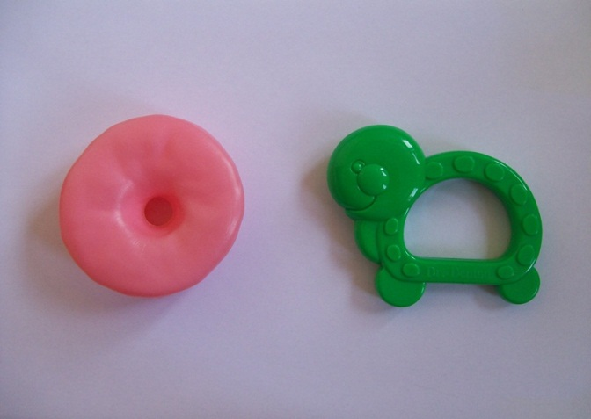 | 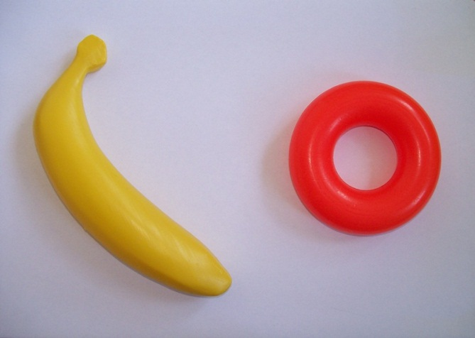
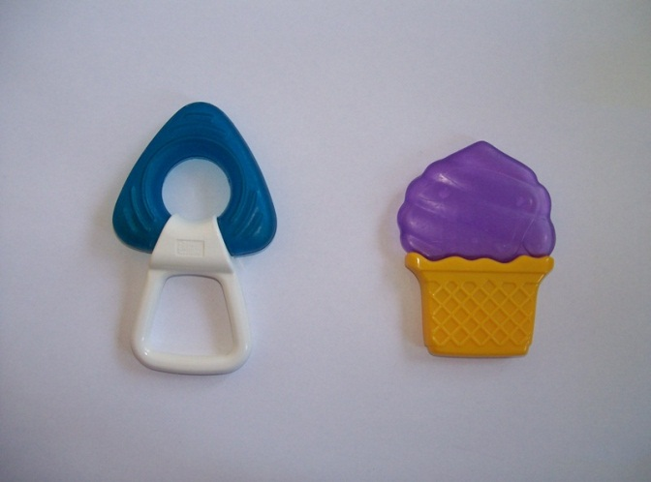 | 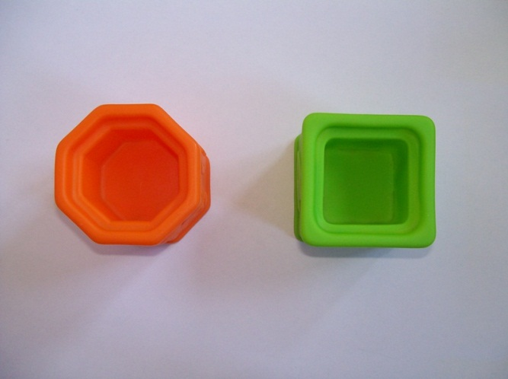
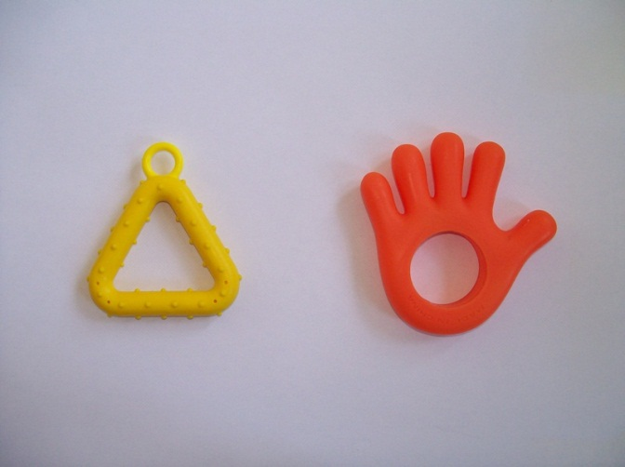 | 